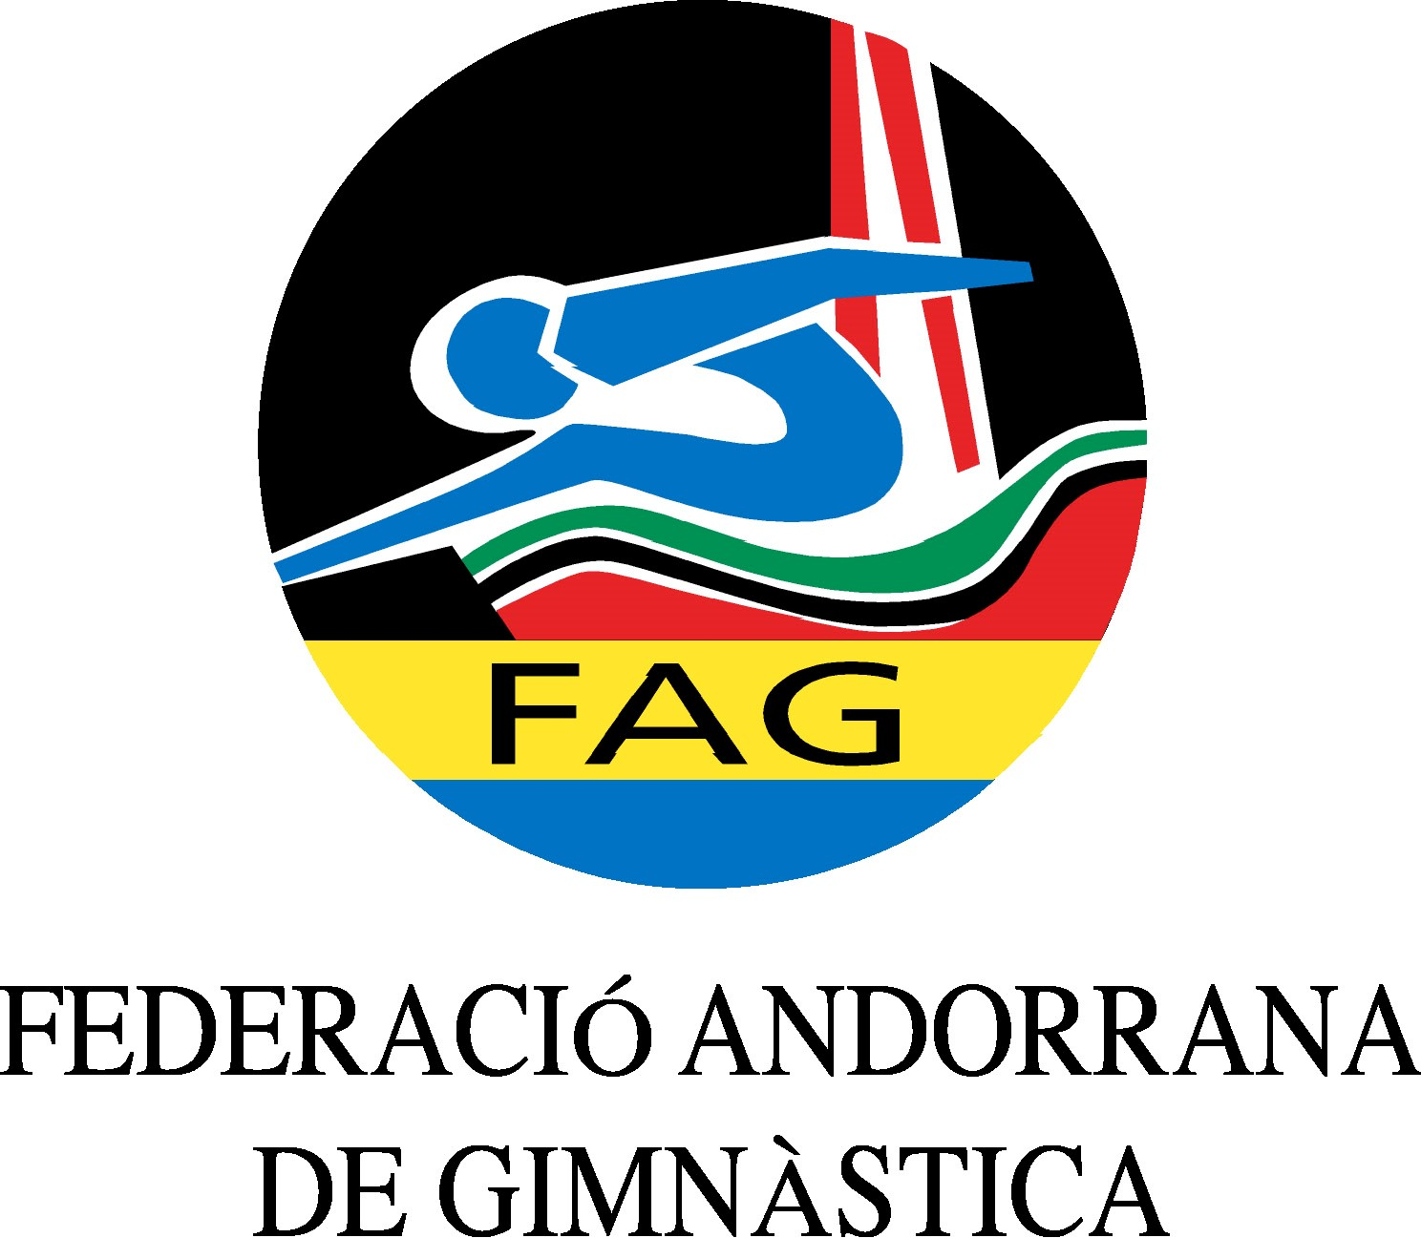
International Tournament
Prejunior, Junior & Senior
March 2020

Form to be sent to:
Organizing Committee / Host Federation
ANDORRAN GYMNASTICS FEDERATION
Federació Andorrana de Gimnàstica
Centre de Tecnificació Esportiva
c/ Narciso Yepes s/n AD300 - Ordino
Ms. Anna Pallarés
Phone: (+376) 343 668
E-mail: andgymcup@gmail.com

Deadline: 01.03.2020
Travel Schedule Form

Federation/club |  | Contact person:
 |  | Phone:
 |  | E-mail:
For earlier arrival or later departure please contact the OC.
Arrival information
# of persons |  |  | # of luggage
Date: |  |  |  |  | Arrival time
By airplane | Airport: |  |  | Flight # |  | From
By train | Station: |  |  | Train # |  | From
By bus | Station: |  |  | Bus # |  | From
By car

Departure information
# of persons |  |  | # of luggage
Date: |  |  |  |  | Departure time
By airplane | Airport: |  |  | Flight # |  | To
By train | Station: |  |  | Train # |  | To
By bus | Station: |  |  | Bus # |  | To
By car

Place and date | Seal of the NF / club | Signature

